Contents
Python if else 1
Chaining comparison operators in Python 7
Python For Loops 8
For in loops 8
Loop Control Statements 10
range() function 11
for-else loop 13
Python While Loops 13
Single statement while block 15
Loop Control Statements 16
while-else loop 17
Python break statement 18
Python Continue Statement 20
Python pass Statement 23
Looping Techniques in Python 24

Python if else
There comes situations in real life when we need to make some decisions and based on these decisions, we decide what should we do next. Similar situations arises in programming also where we need to make some decisions and based on these decision we will execute the next block of code.
Decision making statements in programming languages decides the direction of flow of program execution. Decision making statements available in python are:
- if statement
- if..else statements
- nested if statements
- if-elif ladder
if statement
if statement is the most simple decision making statement. It is used to decide whether a certain statement or block of statements will be executed or not i.e if a certain condition is true then a block of statement is executed otherwise not.
Syntax:

if condition:
# Statements to execute if
# condition is true
Here, condition after evaluation will be either true or false. if statement accepts boolean values – if the value is true then it will execute the block of statements below it otherwise not. We can use condition with bracket ‘(‘ ‘)’ also.
As we know, python uses indentation to identify a block. So the block under an if statement will be identified as shown in the below example:
if condition:
statement1
statement2

# Here if the condition is true, if block
# will consider only statement1 to be inside
# its block.
Flowchart:-
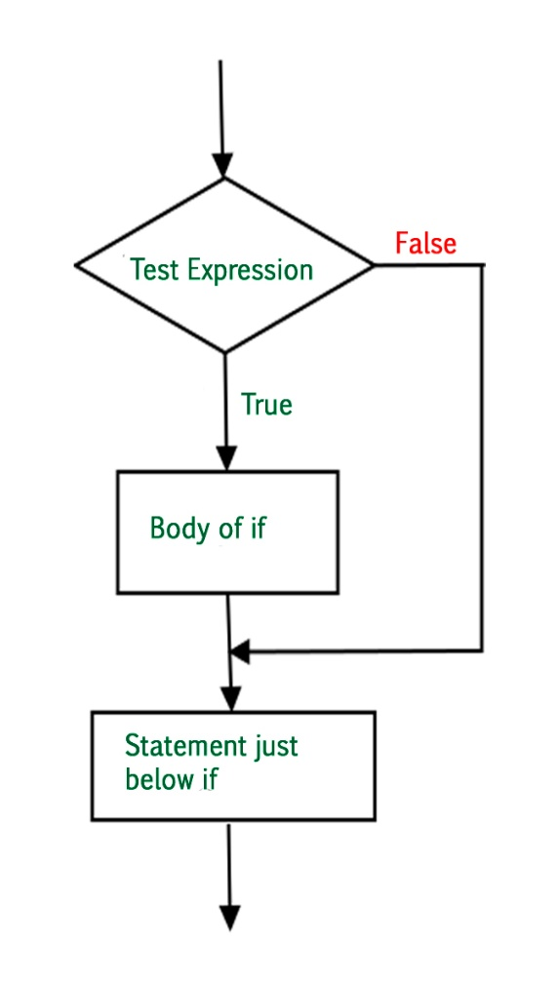
# python program to illustrate If statement

i = 10
if (i > 15):
print ("10 is less than 15")
print ("I am Not in if")
Output:
I am Not in if
As the condition present in the if statement is false. So, the block below the if statement is not executed.
if- else
The if statement alone tells us that if a condition is true it will execute a block of statements and if the condition is false it won’t. But what if we want to do something else if the condition is false. Here comes the else statement. We can use the else statement with if statement to execute a block of code when the condition is false.
Syntax:
if (condition):
# Executes this block if
# condition is true
else:
# Executes this block if
# condition is false
Flow Chart:-
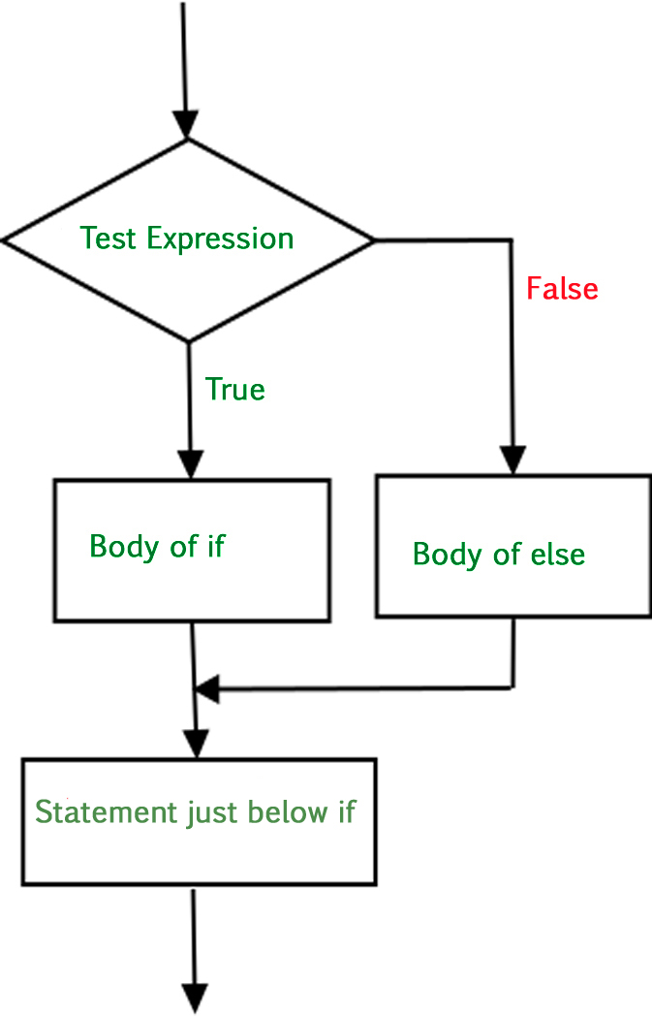

# python program to illustrate If else statement
#!/usr/bin/python

i = 20;
if (i < 15):
print ("i is smaller than 15")
print ("i'm in if Block")
else:
print ("i is greater than 15")
print ("i'm in else Block")
print ("i'm not in if and not in else Block")
Output:
i is greater than 15
i'm in else Block
i'm not in if and not in else Block
The block of code following the else statement is executed as the condition present in the if statement is false after call the statement which is not in block(without spaces).
nested-if
A nested if is an if statement that is the target of another if statement. Nested if statements means an if statement inside another if statement. Yes, Python allows us to nest if statements within if statements. i.e, we can place an if statement inside another if statement.
Syntax:
if (condition1):
# Executes when condition1 is true
if (condition2):
# Executes when condition2 is true
# if Block is end here
# if Block is end here
Flow chart:-
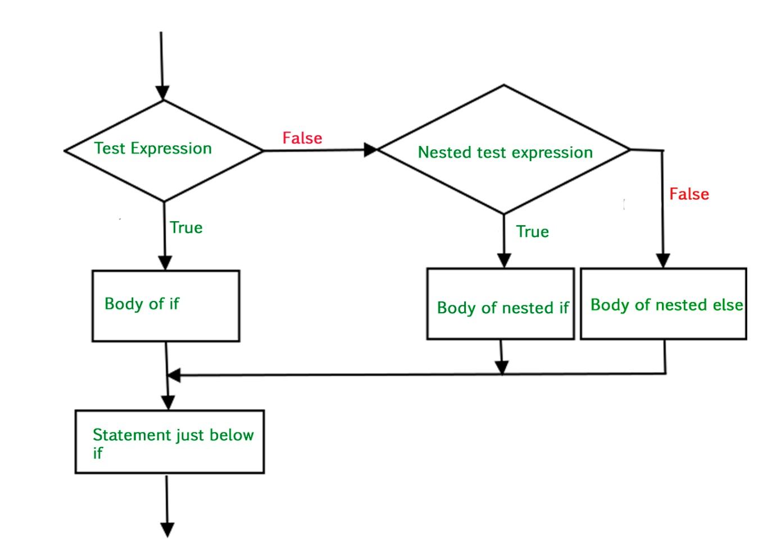

# python program to illustrate nested If statement
#!/usr/bin/python
i = 10
if (i == 10):
# First if statement
if (i < 15):
print ("i is smaller than 15")
# Nested - if statement
# Will only be executed if statement above
# it is true
if (i < 12):
print ("i is smaller than 12 too")
else:
print ("i is greater than 15")
Output:
i is smaller than 15
i is smaller than 12 too
if-elif-else ladder
Here, a user can decide among multiple options. The if statements are executed from the top down. As soon as one of the conditions controlling the if is true, the statement associated with that if is executed, and the rest of the ladder is bypassed. If none of the conditions is true, then the final else statement will be executed.
Syntax:-
if (condition):
statement
elif (condition):
statement
.
.
else:
statement
Flow Chart:-
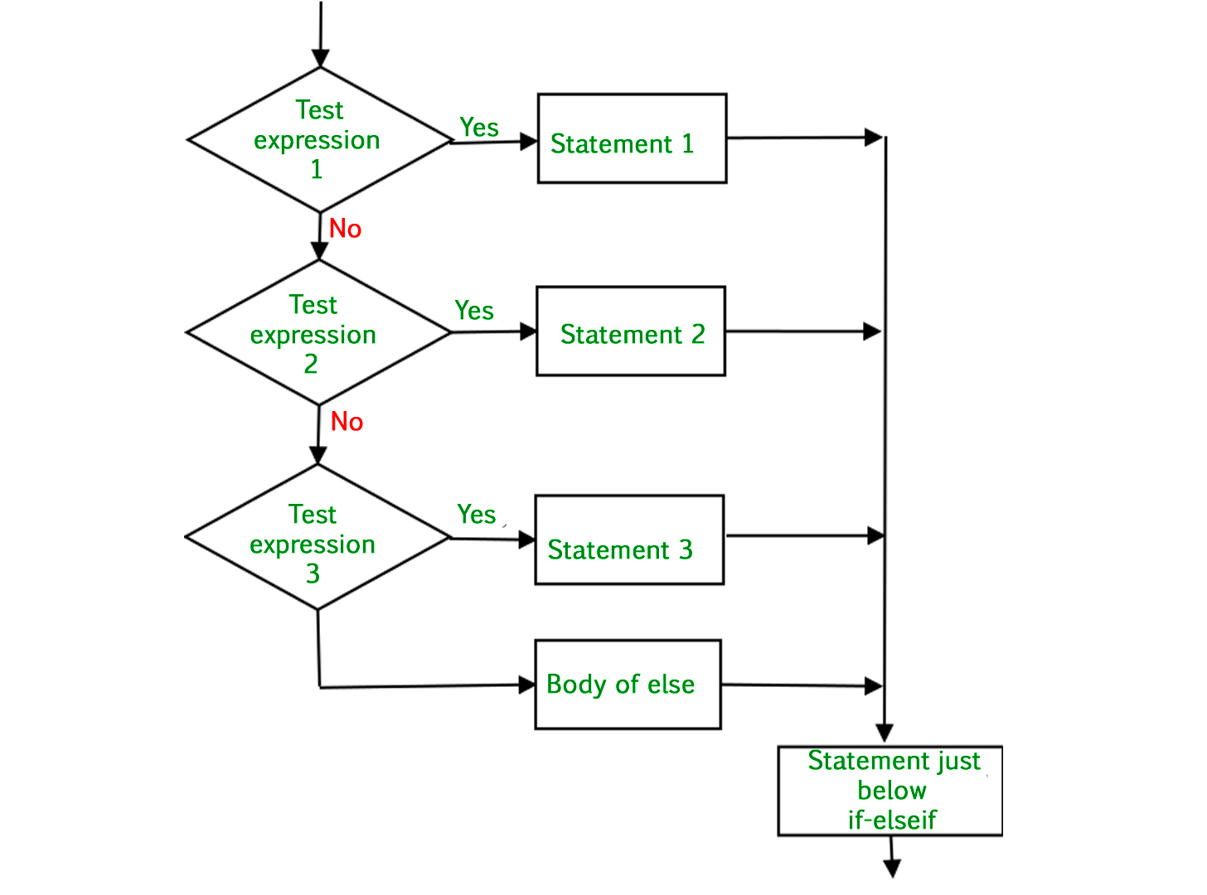
# Python program to illustrate if-elif-else ladder
#!/usr/bin/python

i = 20
if (i == 10):
print ("i is 10")
elif (i == 15):
print ("i is 15")
elif (i == 20):
print ("i is 20")
else:
print ("i is not present")
Output:
i is 20

Chaining comparison operators in Python
Checking more than two conditions is very common in Programming Languages. Let say we want to check below condition:
a < b < c
Most common syntax to do it is as follows:
if a < b and b < c :
{...}
In Python, there is a better way to write this using Comparison operator Chaining. The chaining of operators can be written as follows:
if a < b < c :
{.....}
According to associativity and precedence in Python, all comparison operations in Python have the same priority, which is lower than that of any arithmetic, shifting or bitwise operation. Also unlike C, expressions like a < b < c have the interpretation that is conventional in mathematics.
List of comparison operators in Python:

">" | "<" | "==" | ">=" | "<=" | "!=" | "is" ["not"] | ["not"] "in"
Chaining in Comparison Operators:
- Comparisons yield boolean values: True or False.
- Comparisons can be chained arbitrarily. For example:
x < y <= z is equivalent to x < y and y <= z,
except that y is evaluated only once.
(but in both cases z is not evaluated at all when x < y is found to be false).
- Formally, if a, b, c, …, y, z are expressions and op1, op2, …, opN are comparison operators, then a op1 b op2 c … y opN z is equivalent to a op1 b and b op2 c and … y opN z, except that each expression is evaluated at most once.
- Also,
a op1 b op2 c
doesn’t imply any kind of comparison between a and c, so
a < b > c
is perfectly legal.

# Python code to illustrate
# chaining comparison operators
x = 5
print(1 < x < 10)
print(10 < x < 20 )
print(x < 10 < x*10 < 100)
print(10 > x <= 9)
print(5 == x > 4)
Output:
True
False
True
True
True
Another Example:
# Python code to illustrate
# chaining comparison operators
a, b, c, d, e, f = 0, 5, 12, 0, 15, 15
exp1 = a <= b < c > d is not e is f
exp2 = a is d > f is not c
print(exp1)
print(exp2)
Output:
True
False

Python For Loops
For loops, in general, are used for sequential traversal. It falls under the category of definite iteration. Definite iterations means the number of repetitions is specified explicitly in advance.
Note: In python, for loops only implements the collection-based iteration.

For in loops
For loops are used for sequential traversal. For example: traversing a list or string or array etc. In Python, there is no C style for loop, i.e., for (i=0; i<n; i++). There is “for in” loop which is similar to for each loop in other languages. Let us learn how to use for in loop for sequential traversals.
Syntax:
for var in iterable:
# statements
Here the iterable is a collection of objects like list, tuple. The indented statements inside the for loops are executed once for each item in an iterable. The variable var takes the value of next item of the iterable each time through the loop.
Example:

# Python program to illustrate
# Iterating over a list
print("List Iteration")
l = ["geeks", "for", "geeks"]
for i in l:
print(i)

# Iterating over a tuple (immutable)
print("\nTuple Iteration")
t = ("geeks", "for", "geeks")
for i in t:
print(i)

# Iterating over a String
print("\nString Iteration")
s = "Geeks"
for i in s :
print(i)

# Iterating over dictionary
print("\nDictionary Iteration")
d = dict()
d['xyz'] = 123
d['abc'] = 345
for i in d :
print("% s % d" %(i, d[i]))
Output:
List Iteration
geeks
for
geeks

Tuple Iteration
geeks
for
geeks

String Iteration
G
e
e
k
s

Dictionary Iteration
xyz 123
abc 345
Working of for loop :
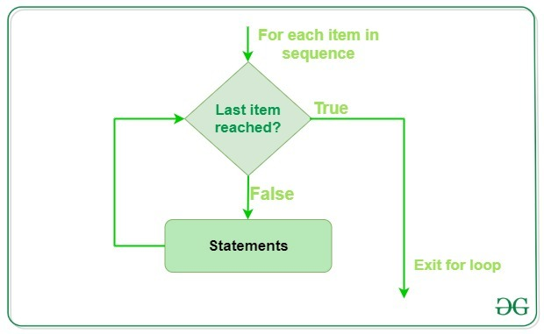

Loop Control Statements
Loop control statements change execution from its normal sequence. When execution leaves a scope, all automatic objects that were created in that scope are destroyed. Python supports the following control statements.
- Continue Statement: It returns the control to the beginning of the loop.

# Prints all letters except 'e' and 's'
for letter in 'geeksforgeeks':
if letter == 'e' or letter == 's':
continue
print('Current Letter :', letter)
var = 10
Output:
Current Letter : g
Current Letter : k
Current Letter : f
Current Letter : o
Current Letter : r
Current Letter : g
Current Letter : k
- Break Statement: It brings control out of the loop.

for letter in 'geeksforgeeks':

# break the loop as soon it sees 'e'
# or 's'
if letter == 'e' or letter == 's':
break

print('Current Letter :', letter)
Output:
Current Letter : e
- Pass Statement: We use pass statement to write empty loops. Pass is also used for empty control statements, function and classes.

# An empty loop
for letter in 'geeksforgeeks':
pass
print('Last Letter :', letter)
Output:
Last Letter : s

range() function
range() is a built-in function of Python. It is used when a user needs to perform an action for a specific number of times. range() in Python(3.x) is just a renamed version of a function called xrange() in Python(2.x). The range() function is used to generate a sequence of numbers.
In simple terms, range() allows user to generate a series of numbers within a given range. Depending on how many arguments user is passing to the function, user can decide where that series of numbers will begin and end as well as how big the difference will be between one number and the next.range() takes mainly three arguments.
- start: integer starting from which the sequence of integers is to be returned
- stop: integer before which the sequence of integers is to be returned.
The range of integers end at stop – 1.
- step: integer value which determines the increment between each integer in the sequence

# Python Program to
# show range() basics

# printing a number
for i in range(10):
print(i, end =" ")
print()

# using range for iteration
l = [10, 20, 30, 40]
for i in range(len(l)):
print(l[i], end =" ")
print()

# performing sum of natural
# number
sum = 0
for i in range(1, 10):
sum = sum + i
print("Sum of first 10 natural number :", sum)
Output:
0 1 2 3 4 5 6 7 8 9
10 20 30 40
Sum of first 10 natural number : 45
Note: To know more about range() click here.

for-else loop
In most of the programming languages (C/C++, Java, etc), the use of else statement has been restricted with the if conditional statements. But Python also allows us to use the else condition with for loops.
Note: The else block just after for/while is executed only when the loop is NOT terminated by a break statement.

# Python program to demonstrate
# for-else loop

for i in range(1, 4):
print(i)
else: # Executed because no break in for
print("No Break\n")

for i in range(1, 4):
print(i)
break
else: # Not executed as there is a break
print("No Break")
Output:
1
2
3
No Break

1

Python While Loops
In Python, While Loops is used to execute a block of statements repeatedly until a given condition is satisfied. And when the condition becomes false, the line immediately after the loop in the program is executed. While loop falls under the category of indefinite iteration. Indefinite iteration means that the number of times the loop is executed isn’t specified explicitly in advance.
Syntax:
while expression:
statement(s)
Statements represent all the statements indented by the same number of character spaces after a programming construct are considered to be part of a single block of code. Python uses indentation as its method of grouping statements. When a while loop is executed, expr is first evaluated in a Boolean context and if it is true, the loop body is executed. Then the expr is checked again, if it is still true then the body is executed again and this continues until the expression becomes false.
Example:

# Python program to illustrate
# while loop
count = 0
while (count < 3):
count = count + 1
print("Hello Geek")

print()

# checks if list still
# contains any element
a = [1, 2, 3, 4]
while a:
print(a.pop())
Output:

Hello Geek
Hello Geek
Hello Geek

4
3
2
1
Working of While Loop :
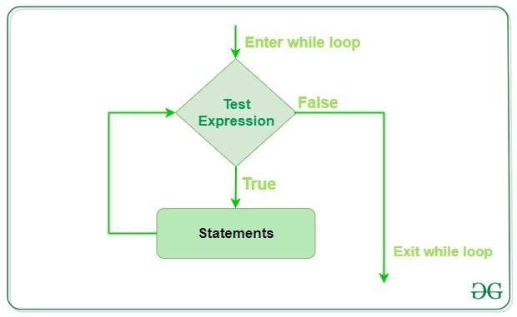

Single statement while block
Just like the if block, if the while block consists of a single statement the we can declare the entire loop in a single line. If there are multiple statements in the block that makes up the loop body, they can be separated by semicolons (;).

# Python program to illustrate
# Single statement while block
count = 0
while (count < 5): count += 1; print("Hello Geek")
Output:
Hello Geek
Hello Geek
Hello Geek
Hello Geek
Hello Geek

Loop Control Statements
Loop control statements change execution from its normal sequence. When execution leaves a scope, all automatic objects that were created in that scope are destroyed. Python supports the following control statements.
- Continue Statement: It returns the control to the beginning of the loop.

# Prints all letters except 'e' and 's'
i = 0
a = 'geeksforgeeks'

while i < len(a):
if a[i] == 'e' or a[i] == 's':
i += 1
continue
print('Current Letter :', a[i])
i += 1
Output:
Current Letter : g
Current Letter : k
Current Letter : f
Current Letter : o
Current Letter : r
Current Letter : g
Current Letter : k
- Break Statement: It brings control out of the loop.

# break the loop as soon it sees 'e'
# or 's'
i = 0
a = 'geeksforgeeks'

while i < len(a):
if a[i] == 'e' or a[i] == 's':
i += 1
break
print('Current Letter :', a[i])
i += 1
Output:
Current Letter : g
- Pass Statement: We use pass statement to write empty loops. Pass is also used for empty control statements, functions and classes.

# An empty loop
a = 'geeksforgeeks'
i = 0

while i < len(a):
i += 1
pass
print('Value of i :', i)
Output:
Value of i : 13

while-else loop
As discussed above, while loop executes the block until a condition is satisfied. When the condition becomes false, the statement immediately after the loop is executed.
The else clause is only executed when your while condition becomes false. If you break out of the loop, or if an exception is raised, it won’t be executed.
Note: The else block just after for/while is executed only when the loop is NOT terminated by a break statement.

# Python program to demonstrate
# while-else loop
i = 0
while i < 4:
i += 1
print(i)
else: # Executed because no break in for
print("No Break\n")

i = 0
while i < 4:
i += 1
print(i)
break
else: # Not executed as there is a break
print("No Break")
Output:
1
2
3
4
No Break

1

Python break statement
Using loops in Python automates and repeats the tasks in an efficient manner. But sometimes, there may arise a condition where you want to exit the loop completely, skip an iteration or ignore that condition. These can be done by loop control statements. Loop control statements change execution from its normal sequence. When execution leaves a scope, all automatic objects that were created in that scope are destroyed. Python supports the following control statements.
- Continue statement
- Break statement
- Pass statement
In this article, the main focus will be on break statement.

Break statement
Break statement in Python is used to bring the control out of the loop when some external condition is triggered. Break statement is put inside the loop body (generally after if condition).
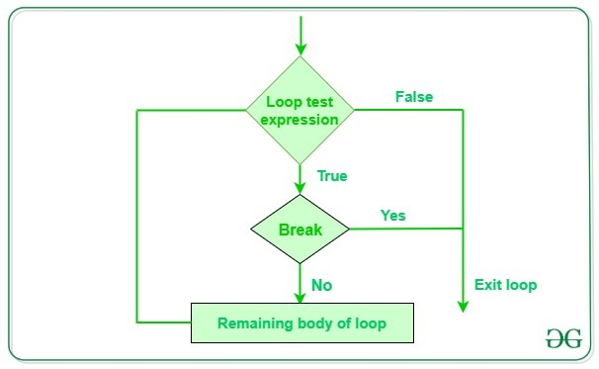
Syntax:

break
Example:

# Python program to
# demonstrate break statement

s = 'geeksforgeeks'
# Using for loop
for letter in s:

print(letter)
# break the loop as soon it sees 'e'
# or 's'
if letter == 'e' or letter == 's':
break

print("Out of for loop")
print()

i = 0

# Using while loop
while True:
print(s[i])

# break the loop as soon it sees 'e'
# or 's'
if s[i] == 'e' or s[i] == 's':
break
i += 1

print("Out of while loop")
Output:
g
e
Out of for loop

g
e
Out of while loop
In the above example, both the loops are iterating the string ‘geeksforgeeks’ and as soon as they encounter the character ‘e’ or ‘s’, the if condition becomes true and the flow of execution is brought out of the loop.

Python Continue Statement
Using loops in Python automates and repeats the tasks in an efficient manner. But sometimes, there may arise a condition where you want to exit the loop completely, skip an iteration or ignore that condition. These can be done by loop control statements. Loop control statements change execution from its normal sequence. When execution leaves a scope, all automatic objects that were created in that scope are destroyed. Python supports the following control statements.
- Continue statement
- Break statement
- Pass statement
In this article, the main focus will be on continue statement.

Continue statement
Continue is also a loop control statement just like the break statement. continue statement is opposite to that of break statement, instead of terminating the loop, it forces to execute the next iteration of the loop.
As the name suggests the continue statement forces the loop to continue or execute the next iteration. When the continue statement is executed in the loop, the code inside the loop following the continue statement will be skipped and the next iteration of the loop will begin.
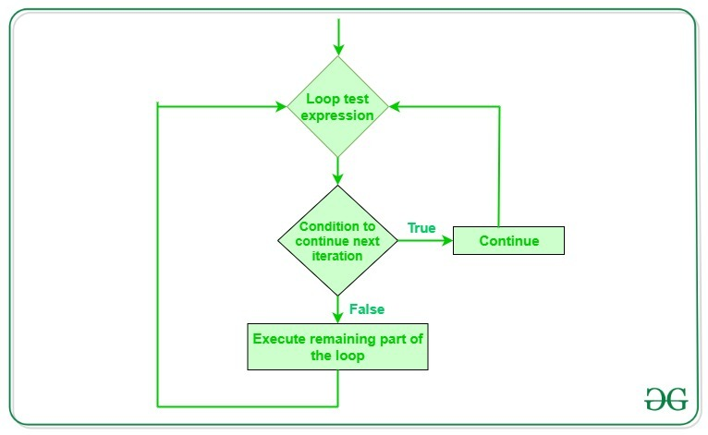
Syntax:

continue
Example:
Consider the situation when you need to write a program which prints the number from 1 to 10 and but not 6. It is specified that you have to do this using loop and only one loop is allowed to use.
Here comes the usage of continue statement. What we can do here is we can run a loop from 1 to 10 and every time we have to compare the value of iterator with 6. If it is equal to 6 we will use the continue statement to continue to next iteration without printing anything otherwise we will print the value.
Below is the implementation of the above idea:
filter_none
edit
play_arrow
brightness_4
# Python program to
# demonstrate continue
# statement

# loop from 1 to 10
for i in range(1, 11):

# If i is equals to 6,
# continue to next iteration
# without printing
if i == 6:
continue
else:
# otherwise print the value
# of i
print(i, end = " ")
Output:
1 2 3 4 5 7 8 9 10
The continue statement can be used with any other loop also like while in a similar way as it is used with for loop above.

Python pass Statement
The pass statement is a null statement. But the difference between pass and comment is that comment is ignored by the interpreter whereas pass is not ignroed.
The pass statement is generally used as a placeholder i.e. when the user does not know what code to write. So user simply places pass at that line. Sometimes, pass is used when the user doesn’t want any code to execute. So user simply places pass there as empty code is not allowed in loops, function definitions, class definitions, or in if statements. So using pass statement user avoids this error.
Syntax:
pass
Example 1: Pass statement can be used in empty functions
- Python3

def geekFunction:
pass
Example 2: pass statement can also be used in empty class

- Python3

class geekClass:
pass
Example 3: pass statement can be used in for loop when user doesn’t know what to code inside the loop
- Python3

n = 10
for i in range(n):

# pass can be used as placeholder
# when code is to added later
pass
Example 4: pass statement can be used with conditional statements
- Python3

a = 10
b = 20

if(a<b):
pass
else:
print("b<a")
Example 5: lets take another example in which the pass statement get executed when the condition is true
- Python3

li =['a', 'b', 'c', 'd']

for i in li:
if(i =='a'):
pass
else:
print(i)
Output:
b
c
d

Looping Techniques in Python
Python supports various looping techniques by certain inbuilt functions, in various sequential containers. These methods are primarily verya useful in competitive programming and also in various project which require a specific technique with loops maintaining the overall structure of code.
Where they are used ?
Different looping techniques are primarily useful in the places where we don’t need to actually manipulate the structure and ordering of overall container, rather only print the elements for a single use instance, no inplace change occurs in the container. This can also be used in instances to save time.
Different looping techniques using Python data structures are:
- Using enumerate(): enumerate() is used to loop through the containers printing the index number along with the value present in that particular index.

# python code to demonstrate working of enumerate()

for key, value in enumerate(['The', 'Big', 'Bang', 'Theory']):
print(key, value)
Output :

0 The
1 Big
2 Bang
3 Theory
- Using zip(): zip() is used to combine 2 similar containers(list-list or dict-dict) printing the values sequentially. The loop exists only till the smaller container ends. The detailed explanation of zip() and enumerate() can be found here.

# python code to demonstrate working of zip()

# initializing list
questions = ['name', 'colour', 'shape']
answers = ['apple', 'red', 'a circle']

# using zip() to combine two containers
# and print values
for question, answer in zip(questions, answers):
print('What is your {0}? I am {1}.'.format(question, answer))
Output :
What is your name? I am apple.
What is your color? I am red.
What is your shape? I am a circle.
- Using iteritem(): iteritems() is used to loop through the dictionary printing the dictionary key-value pair sequentially.
- Using items(): items() performs the similar task on dictionary as iteritems() but have certain disadvantages when compared with iteritems().
  - It is very time consuming. Calling it on large dictionaries consumes quite a lot of time.
  - It takes a lot of memory. Sometimes takes double the memory when called on dictionary.
- Example 1:

# python code to demonstrate working of iteritems(),items()

d = { "geeks" : "for", "only" : "geeks" }

# using iteritems to print the dictionary key-value pair
print ("The key value pair using iteritems is : ")
for i,j in d.iteritems():
print i,j

# using items to print the dictionary key-value pair
print ("The key value pair using items is : ")
for i,j in d.items():
print i,j
Output:
The key value pair using iteritems is :
geeks for
only geeks
The key value pair using items is :
geeks for
only geeks
- Example 2:

# python code to demonstrate working of items()

king = {'Akbar': 'The Great', 'Chandragupta': 'The Maurya',
'Modi' : 'The Changer'}

# using items to print the dictionary key-value pair
for key, value in king.items():
print(key, value)
Output :
Akbar The Great
Modi The Changer
Chandragupta The Maurya
Note: iteritems() has been removed from the python 3.x it only works in python 2.x.Instead use dict.items().
  - Using sorted(): sorted() is used to print the container is sorted order. It doesn’t sort the container, but just prints the container in sorted order for 1 instance. Use of set() can be combined to remove duplicate occurrences.
- Example 1:

# python code to demonstrate working of sorted()

# initializing list
lis = [ 1 , 3, 5, 6, 2, 1, 3 ]

# using sorted() to print the list in sorted order
print ("The list in sorted order is : ")
for i in sorted(lis) :
print (i,end=" ")

print ("\r")

# using sorted() and set() to print the list in sorted order
# use of set() removes duplicates.
print ("The list in sorted order (without duplicates) is : ")
for i in sorted(set(lis)) :
print (i,end=" ")
Output:
The list in sorted order is :
1 1 2 3 3 5 6
The list in sorted order (without duplicates) is :
1 2 3 5 6
- Example 2:

# python code to demonstrate working of sorted()

# initializing list
basket = ['guave', 'orange', 'apple', 'pear',
'guava', 'banana', 'grape']

# using sorted() and set() to print the list
# in sorted order
for fruit in sorted(set(basket)):
print(fruit)
Output:
apple
banana
grape
guava
guave
orange
pear
  - Using reversed(): reversed() is used to print the values of container in the reversed order.
Note: It does not reflect any changes to the original list
- Example 1:

# python code to demonstrate working of reversed()

# initializing list
lis = [ 1 , 3, 5, 6, 2, 1, 3 ]

# using revered() to print the list in reversed order
print ("The list in reversed order is : ")
for i in reversed(lis) :
print (i,end=" ")
Output:
The list in reversed order is :
3 1 2 6 5 3 1
- Example 2:

# python code to demonstrate working of reversed()

# using reversed() to print in reverse order
for i in reversed(range(1, 10, 3)):
print (i)
Output :
7
4
1
Advantage of using above techniques over for, while loop
  - These techniques are quick to use and reduces coding effort. for, while loops needs the entire structure of container to be changed.
  - These Looping techniques do not require any structural changes to container. They have keywords which present the exact purpose of usage. Whereas, no pre-predictions or guesses can be made in for, while loop i.e not easily understandable the purpose at a glance.
  - Looping technique make the code more concise than using for, while loopings.

